WELCOME!

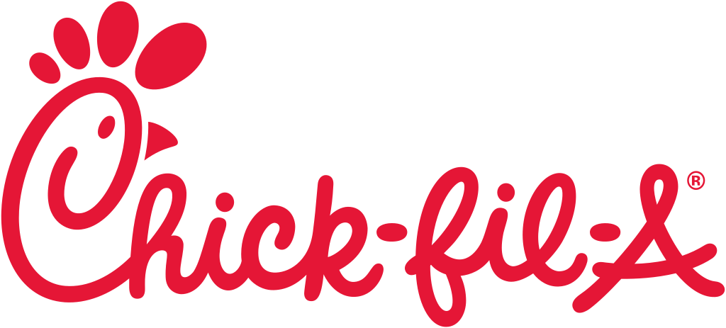

Certified Trainer
Certified Trainer Role Description
The Mission of a Certified Trainer:
"To serve the Chick-fil-A brand by equipping Team Members with the resources and skills to execute Operational Excellence and to bring the Chick-fil-A culture to every Restaurant through Team Member training and coaching."
Certified Trainer Profile:
KNOWLEDGE
Proficient in Chick-fil-A brand standards and procedural knowledge
  - Foundation: Demonstrates a working knowledge of Chick-fil-A processes and procedures
  - Work Product: Executes in accordance with Chick-fil-A operating standards
  - Resources: Incorporates resources into all training experiences
  - Growth Mindset: Shows an eagerness and ability to learn quickly
TRAINING SKILL
Proficient ability to utilize training resources and skills
  - Communication: Communicates clearly and efficiently
  - Accountability: Consistently welcomes and provides accurate and timely feedback
  - Strategic: Utilizes effective questioning and training tools to facilitate learning
  - Emotional Intelligence: Adjusts training approach to accommodate learning needs
SPEED & ACCURACY
Proficient capacity to execute Chick-fil-A procedures with speed and accuracy
  - High Standards: Strives for personal excellence and exhibits organization
  - Flexibility: Adjusts quickly to changes and remains calm under pressure
  - Efficiency: Demonstrates effective time management skills
  - Proactivity: Assesses needs and responds in a timely manner
LEADERSHIP
Expert ability to demonstrate leadership capacity
  - Integrity: Upholds ethical and Chick-fil-A standards
  - Ownership: Takes responsibility for the outcomes of decisions
  - Professionalism: Exhibits maturity in communication and behavior
  - Coach: Influences other trainees to achieve greater performance and outcomes
ATTITUDE
Expert ability to demonstrate a genuine and positive attitude
  - Enthusiasm: Exhibits a passion for training and excitement for Chick-fil-A
  - Teamwork: Enjoys collaboration and is willing to serve in any capacity
  - Respect: Displays confident humility in interaction with authority, peers, and trainees
  - Optimism: Demonstrates patience with trainees and a commitment to their success

Training CEM Scores for 2021

CEM OVERALL SATISFACTION-
- Goal: 76% 2019: 75%
- Beginning of 2020: 76% (Nov-Jan. CEM)
- Current: 76%
- Above or below goal? Right on!
- New goal for 2021: 77%

ATTENTIVE AND COURTEOUS EMPLOYEES-
- Goal: 79% 2019: 79%
- Beginning of 2020: 78% (Nov-Jan. CEM)
- Current: 82%
- Above or below goal? Above!
- New goal for 2021: 81%

EASE OF PLACING ORDER-
- Goal: 80% 2019: 79%
- Beginning of 2020: 79% (Nov-Jan. CEM)
- Current: 81%
- Above or below goal? Above!
- New goal for 2021: 81%

SEE IT. SET IT. SHARE IT!

What do we get graded on? These are the survey questions that affect our CEM Scores…

Chick-Fil-A Survey Questions

- Please rate your overall satisfaction with your most recent visit to this Chick-fil-A®.

- The taste of your food.

- The portion size of your food.

- The actions this Chick-fil-A took to protect the health and safety of its employees. If you did not notice, select N/A.

- Providing fast service.

- The actions this Chick-fil-A took to protect the health and safety of customers. If you did not notice, select N/A.

- Having attentive and courteous employees.

- The ease of placing your order.

- The exterior cleanliness of the Chick-fil-A® you visited.

- The ease of receiving your order.

- The temperature of your food.

- The overall value for the experience.

- Did you experience a problem during your visit?

- Was your order fulfilled accurately?

- I believe this Chick-fil-A cares about me as a customer.

CEM…HOW DOES IT ALL COME TOGETHER?
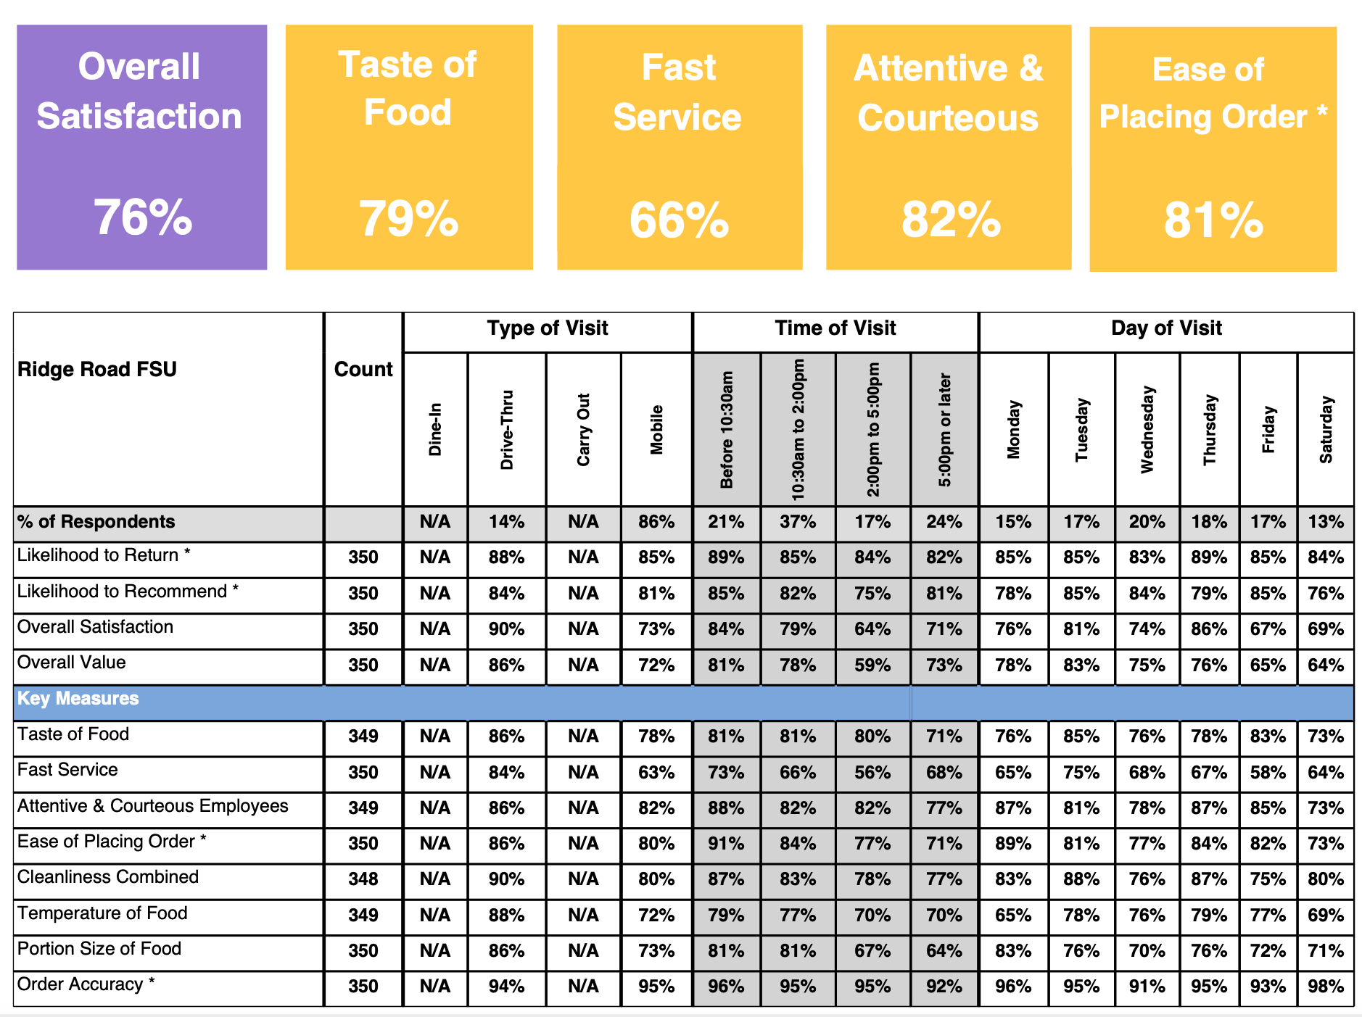

CEM OVERALL SATISFACTION: A COMBINATION OF ALL THE CATEGORIES AVERAGED TOGETHER

TASTE OF FOOD: QUALITY, ARE WE MAKING SURE THAT OUR FOOD IS FRESH? (MAKE SURE WE DON’T HAVE A LOT OF FOOD DURING SLOW TIMES)

FAST SERVICE: ARE WE GOING FAST? REMEMBER, ITS ALL ABOUT PERCEPTION! CLOSE YOUR GAPS AT ALL TIMES, PULL UP CARS ALL THE WAY WHEN RUNNING OUT FOOD

ATTENTIVE AND COURTEOUS: IS THE TEAM MEMBER FRIENDLY/APPROACHABLE?

EASE OF PLACING ORDER: HOW GOOD IS THE TEAM MEMBERS KNOWLEDGE WHEN TAKING ORDERS?

